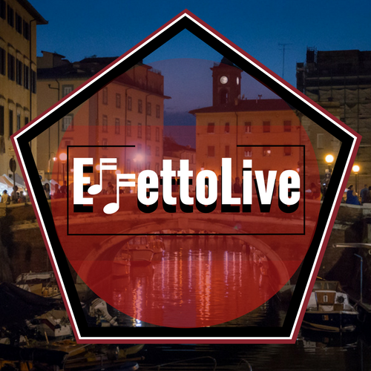
Modulo ammissione: EffettoLive 2018

NOME GRUPPO/SINGOLO ARTISTA: __________________________________________________

____________________________________________________________________________________

GENERE MUSICALE:_________________________________________________________________

____________________________________________________________________________________

LUOGO DI PROVENIENZA: ___________________________________________________________

____________________________________________________________________________________

MEMBRI: ___________________________________________________________________________

____________________________________________________________________________________

____________________________________________________________________________________

____________________________________________________________________________________

____________________________________________________________________________________

____________________________________________________________________________________

____________________________________________________________________________________

BIO: _______________________________________________________________________________

____________________________________________________________________________________

____________________________________________________________________________________

____________________________________________________________________________________

____________________________________________________________________________________

____________________________________________________________________________________

____________________________________________________________________________________

____________________________________________________________________________________

CONTATTI: _________________________________________________________________________

Indirizzi utili:
mail: effettolive@yahoo.com
pagina facebook: http://www.facebook.com/EffettoLive

